**RAJALAKSHMI ENGINEERING COLLEGE**

**RAJALAKSHMI NAGAR, THANDALAM – 602 105**



|  |
| --- |
| **CS23A34**  **USER INTERFACE AND DESIGN LAB** |
| **Laboratory Observation Notebook** |

# Name : SANJAY KUMAR.K

# Year/Branch/Section : II/CSE/C

# Register No. : 230701289 Semester : IV Academic Year: 2024-25

**Ex. No.: 10**

**Register No.: 230701289**   **Name: SANJAY KUMAR.K**

**Create a data visualization (e.g., pie charts, bar graphs) for an inventory management system using javascript**

**AIM:**

The aim is to create data visualizations, such as pie charts and bar graphs, for an inventory management system using JavaScript.

**PROCEDURE:**

Step 1: Set Up Your HTML File

First, create an HTML file to hold your canvas for the chart and include Chart.js. html

<!DOCTYPE html>

<html lang="en">

<head>

<meta charset="UTF-8">

<meta name="viewport" content="width=device-width, initial-scale=1.0">

<title>Inventory Management Visualization</title>

<style> body { fontfamily: Arial, sans-serif; text-align: center; margin:

50px;

}

canvas { margin: 20px auto;

}

</style>

</head>

<body>

<h1>Inventory Management System</h1>

<canvas id="pieChart" width="400" height="400"></canvas>

<canvas id="barChart" width="400" height="400"></canvas>

<script src="https://cdn.jsdelivr.net/npm/chart.js"></script>

<script src="script.js"></script>

</body>

</html>

Step 2: Create the JavaScript File for Charts

Next, create a JavaScript file (script.js) to handle the data visualization logic.

javascript

// script.js

// Data for the inventory const inventoryData = { labels: ['Electronics', 'Clothing', 'Home Appliances', 'Books', 'Toys'], datasets: [

{ label: 'Items in Stock', data: [200, 150, 100, 80, 50], backgroundColor: [

'#FF6384',

'#36A2EB',

'#FFCE56',

'#4BC0C0',

'#9966FF'

],

}

]

};

// Creating the Pie Chart const ctxPie =

document.getElementById('pieChart').getContext('2d'); const pieChart = new Chart(ctxPie, { type: 'pie', data:

inventoryData, options: { responsive: true, title: { display: true, text:

'Inventory Distribution'

}

}

});

// Creating the Bar Chart const ctxBar =

document.getElementById('barChart').getContext('2d'); const barChart = new Chart(ctxBar, { type: 'bar', data: inventoryData, options: { responsive: true, title: { display: true, text: 'Items in Stock by Category'

}, scales: { yAxes: [{ ticks: { beginAtZero: true

}

}]

}

}

});

**OUTPUT:**

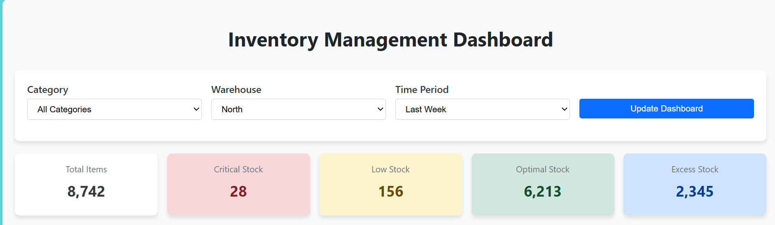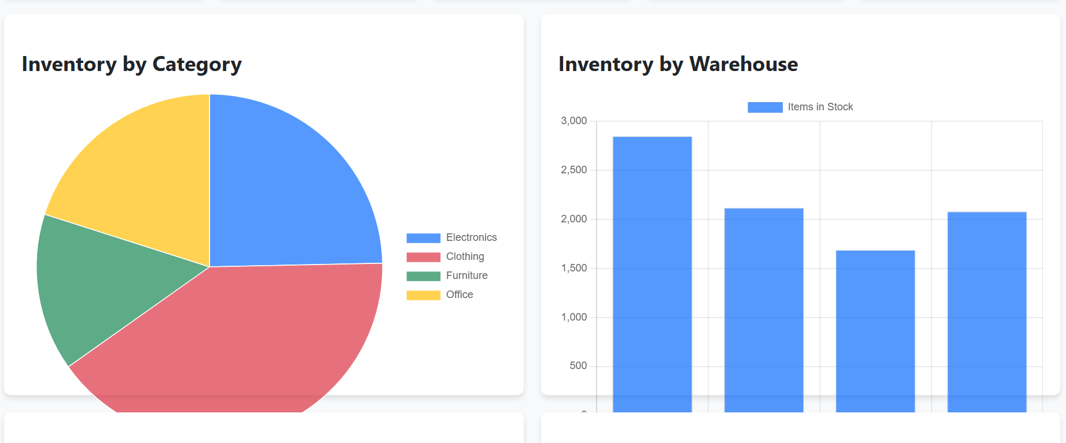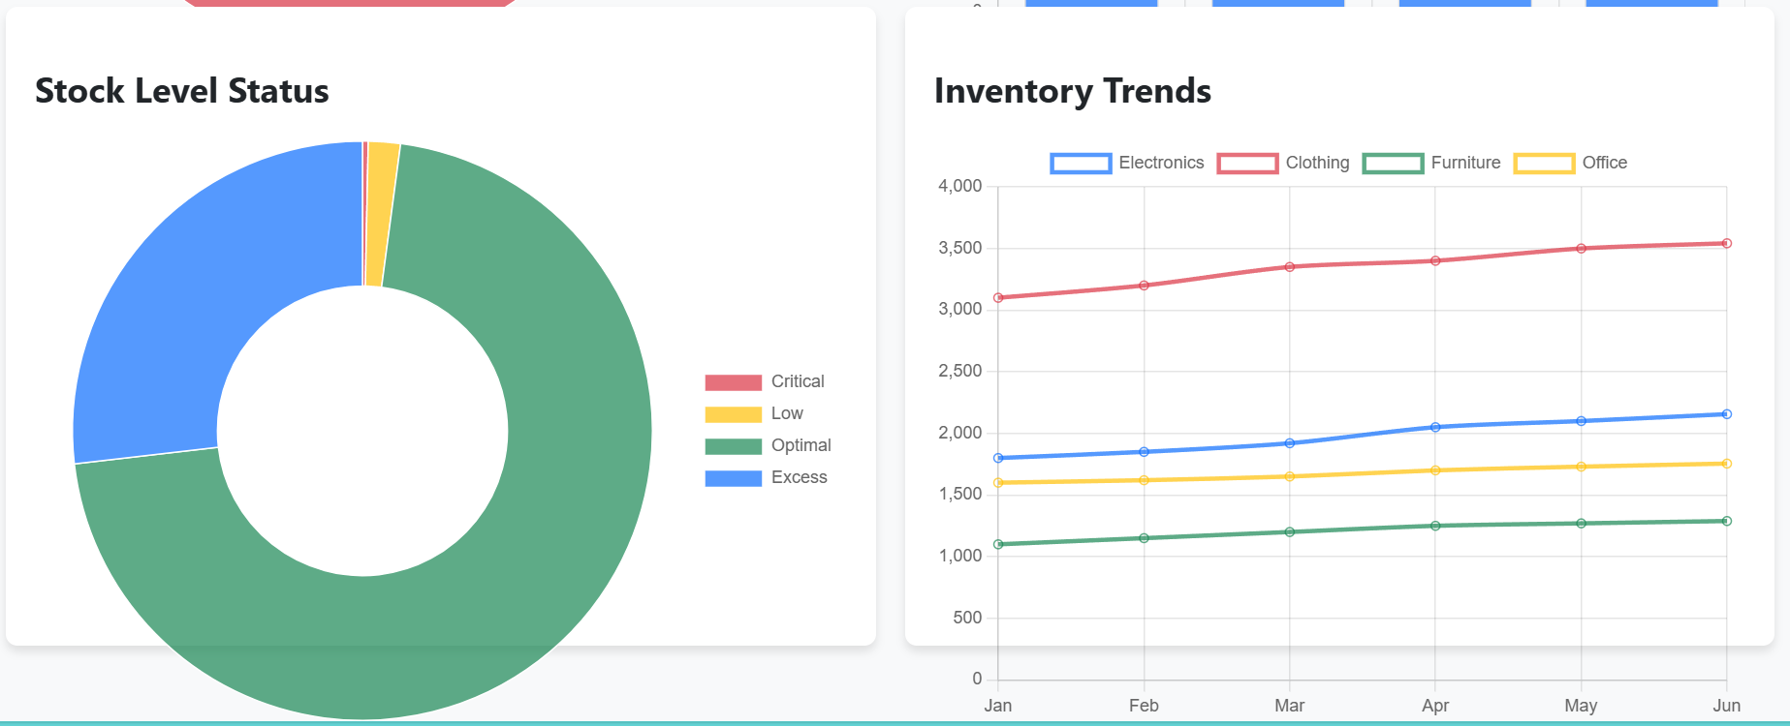

**RESULT:**

Hence we have created data visualizations, such as pie charts and bar graphs, for an inventory management system using JavaScript